**PROJECT REPORT**

**Introduction:**

This Global Air Transportation Network dataset a comprehensive collection of information on airports, airlines and their routes. It contains information such as names, cities, countries, codes (IATA and ICAO) longitudes, latitudes and altitudes of airports across the world with detailed time zone and daylight saving time data.

Additionally, this includes information about airlines including their IDs, name aliases, IATA and ICAO codes, callsigns country of origin and active/inactive status.

Similarly, it also covers route details such as airline sources to destination airports along with essential details like codeshare stakeholder if any stops required during this journey along with the type of aircraft being used for that particular journey.

This dataset has been compiled through meticulous labor by researchers all over the world to give you a comprehensive detail into air transportation networks from around the globe.

It requires your generous donations in order for them to keep updating this data source so please do donate if possible.

**Purpose:**

In this project, we are going to give you a global vision of the air transports industry.

This project includes definition of Air transport, characteristics, History, Logistics Chain, types , Importance, advantages, Disadvantages, Infrastructure of Air transport and its Impact on environment.

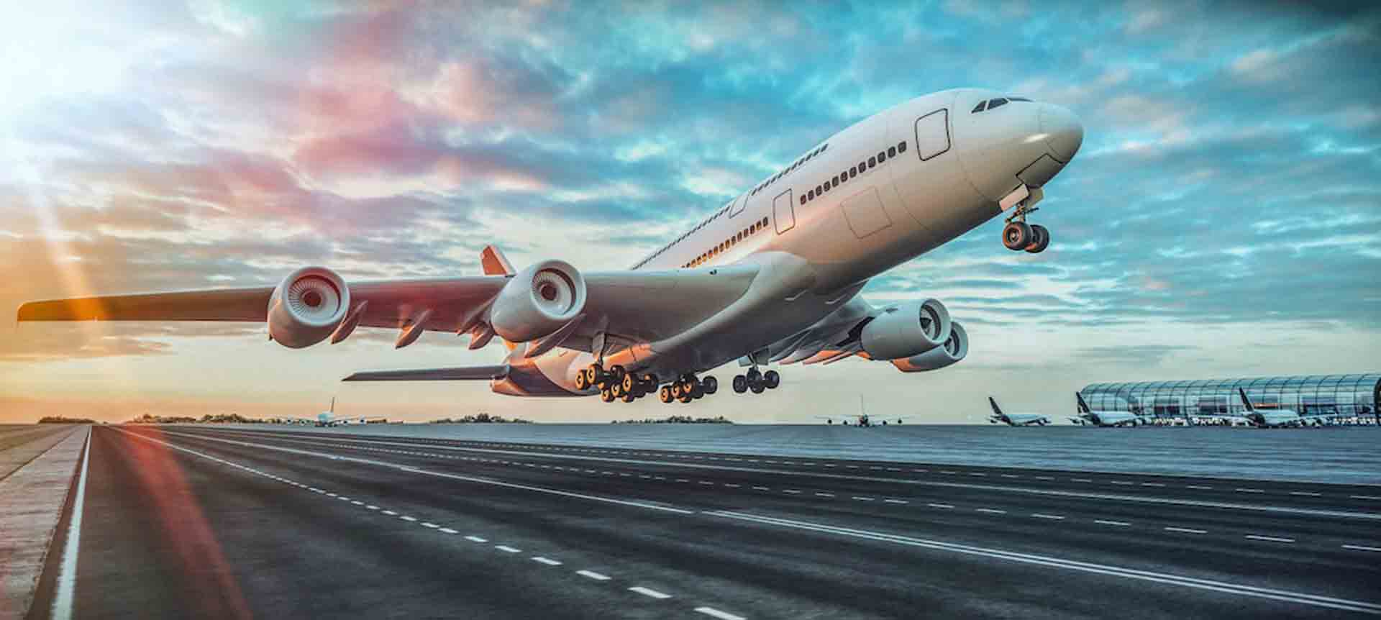

**Empathy map:**

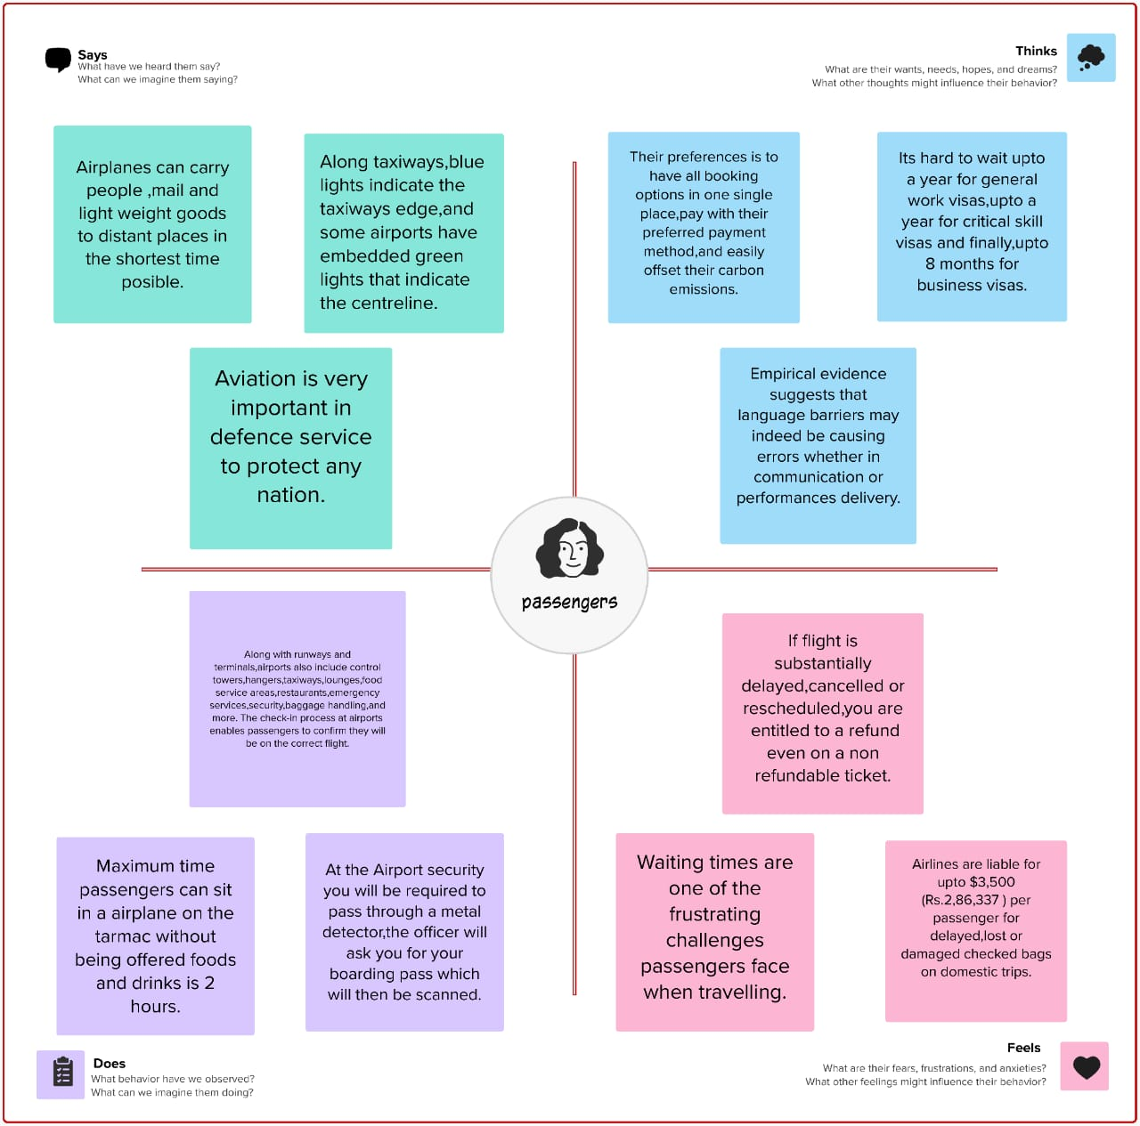

**Brainstorming Map:**

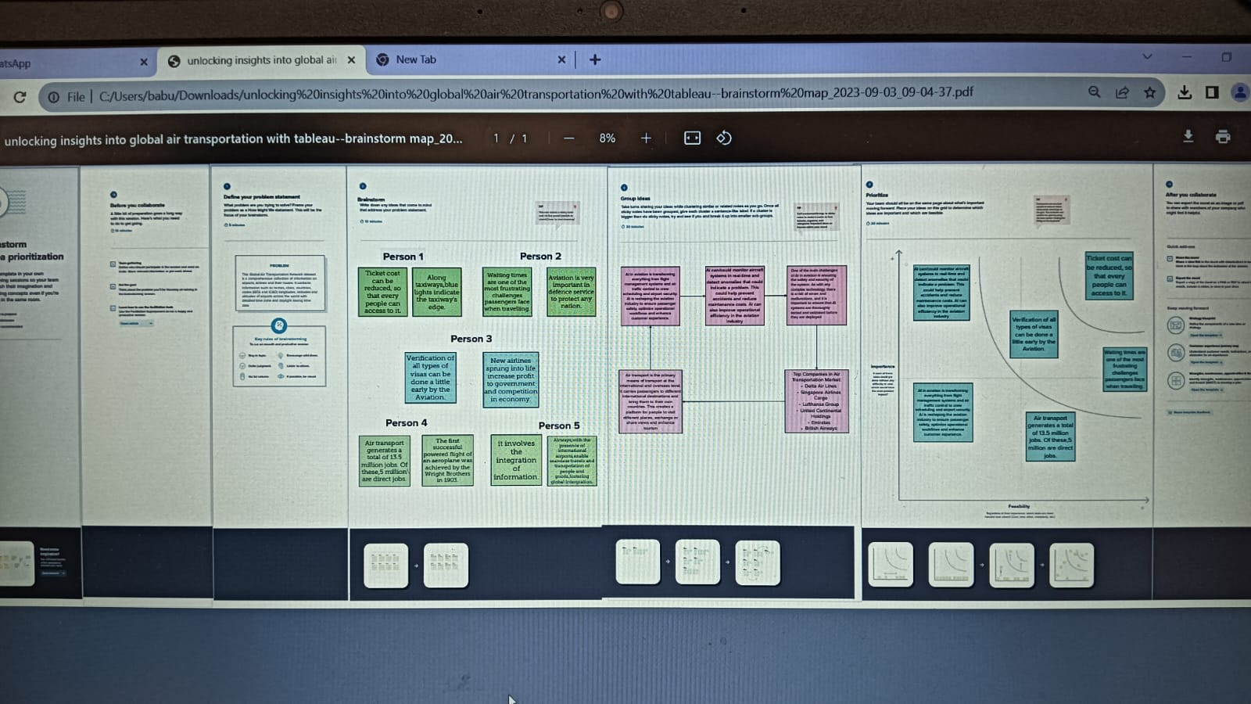

**Advantages and Disadvantages:**

**Advantages:**

**Speed:** It is the fastest mode of transport that exists and, therefore, it is especially recommended when time is an important factor.

**There are no physical barriers:** Thanks to this it is possible to make a trip without interruption choosing the shortest and most direct route through seas, mountains.

**Easy access:** Air transport can transport goods to areas that are not easily accessible by other means of transport.

Suitable for transporting high-value or perishable goods over long distances.

**Disadvantages:**

**Very expensive economically:** It is the most expensive means of transport.

**Uncertain:** Air transport is largely conditioned by weather conditions. Snow, rain, fog, etc., can cause the cancellation of scheduled flights and the suspension of air service.

Not suitable for cheap and high volume goods due to its limited capacity and high cost.

**Legal restrictions:** Many countries have legal restrictions in the interest of their own security.

**Applications:**

1. **Boost to Tourism. ...**
2. **Trade and Commerce. ...**
3. **Foreign Investment and Business. ...**
4. **Connectivity. ...**
5. **Infrastructure Development. ...**
6. **Contribution to GDP.**

**Conclusion:**

In conclusion, the Indian aviation industry has undergone significant developments and growth in recent years. The expansion of regional connectivity, emergence of low-cost carriers, increased investment in infrastructure, and adoption of technological advancements have all contributed to the growth of the industry.

The Indian government has undertaken several initiatives to develop and modernize airports, establish a digital sky platform, and promote regional connectivity through the UDAN scheme. These efforts have led to an increase in passenger traffic, reduced fares, and enhanced the overall passenger experience. The industry's growth and development is expected to continue in the coming years, making India an increasingly important player in the global aviation industry.

**Future Scope:**

The industry has a number of domestic and international airlines, as well as a large network of airports.

The future of the aviation industry in India is likely to see continued growth and expansion, driven by factors such as a growing middle class, increased tourism, and government policies supporting the industry.

However, the industry is also likely to face a number of challenges, including infrastructure constraints and competition from low-cost carriers.